CENWP-OD-B 12 August 2024

MEMORANDUM FOR THE RECORD

SUBJECT: 24BON043 MFR AFF Valve 15 Pacific Lamprey Mortality

On the morning of 12 August 2024, CRITFC Biologists notified Project Biologists of one adult Pacific Lamprey mortality discovered on the Adult Fish Facility’s valve 15 trash rack. The fish was measured, scanned for PIT tags, inspected, and returned to the river.

- Species – Pacific Lamprey (Entosphenus tridentatus)
- Origin – Unknown
- Length – 61.6cm
- Marks and tags – None
- Marks and Injuries found on carcass – Slight redness on posterior portion of body, unknown cause.
- Cause and Time of Death – Unknown
- Future and Preventative Measures – N/A

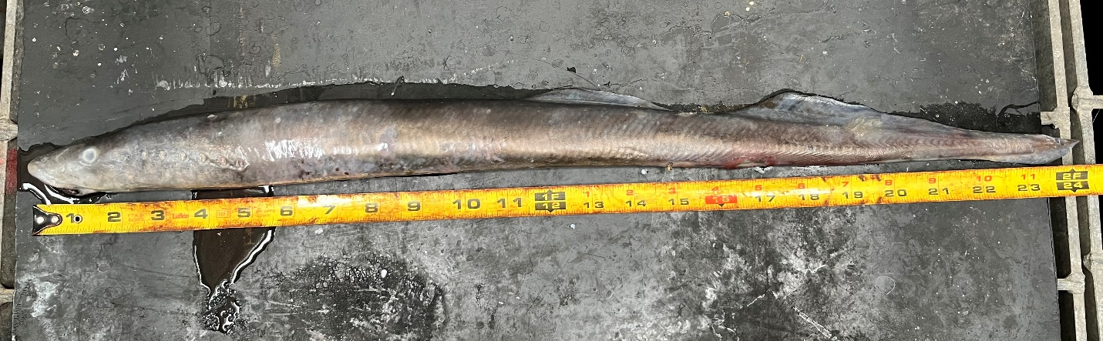

Sincerely,
Bonneville Project Fisheries

